**CLINIC MANAGEMENT SYSTEM**

**A PROJECT REPORT**

*Submitted by*

**Piyush Sankhala 205119065**

**And**

**Surbhi Dabhade 205119105**

*In partial fulfillment in the award of degree of*

**MASTER OF COMPUTER APPLICATIONS**



**NATIONAL INSTITUTE OF TECHNOLOGY**

**TIRUCHIRAPPALLI**

**JULY 2020**

**COMPUTER APPLICATIONS**

**DECLARATION**

**I hereby declare that the project entitled “CLINIC Management System” which is submitted by us for the partial fulfillment of Master of Computer Applicationof National Institute of Technology, Tiruchirappalli comprises of our own work and due acknowledgement has been made in text to all other material used.**

**The matter embodied in this project work is authenticated and is genuinely done by us and has not been submitted to this university or any other university/institute.**

**We have completed this project work during our 2nd semester session under the supervision of Dr. P. CHITRA.**

**Signature of students:**

**Piyush Sankhala -**

**Surbhi Dabhade –**

**Date –**

**Place -**

**CERTIFICATE FROM GUIDE**

**It is to certify that project on “CLINIC Management System” submitted by Piyush Sankhala (205119065) and his team members Surbhi Dabhade (205119105) to National Institute of Technology, Tiruchirappalli has been completed under my supervision and the work is carried out and presented in a manner required for its acceptance in partial fulfillment for the award of degree of “Master of Computer Application” 2nd semester.**

**Project Guide**

**Signature**

**Name: Dr. P. CHITRA MAM**

**Date:**

**CERTIFICATE**

**It is to certify that we have examined the project on “CLINIC Management System” submitted by Piyush Sankhala (205119065)and his team members Surbhi Dabhade (205119105) to National Institute of Technology, Tiruchirappalli and hereby accord our approval of it as a study carried out and presented in a manner required for its acceptance in partial fulfillment for the award of degree on “Master of Computer Application 2ndsemester.**

**Internal Examiner:- External Examiner:-**

**Signature:- Signature:-**

**Name:- Name :-**

**Date:- Date :-**

**ACKNOWLEDGEMENT**

**We acknowledge our sincere thanks to those who contributed significantly to the project. It is a pleasure to extend deep gratitude to our internal guide Dr. P. CHITRA, NITT, for her valuable guidance and support and to continuously prompt me for the progress of the project. I thank her for her valuable suggestion towards my project, which helped me in making this project more efficient and user friendly.**

**I thank and acknowledge each and every one effort that helped us in some or the other way for small and significant things.**

Student Signature - ………………

Student Name & Roll No…………………

**ABSTRACT**

* The main purpose of developing this project is to manage CLINIC record. The information related to CLINIC include CLINIC Id, CLINIC Name, CLINIC salary and CLINIC designation.
* We can operate various operations like insert, display, update and delete the CLINIC details.
* We have developed this project in C and C++ programming language and our main focus is on user interface.

**Table of Contents**

* **Declaration**
* **Certificate**
* **Acknowledgement**
* **Abstract**

1. **Introduction** 
   1. The Client Organization
   2. Problem Definition
   3. Aim
   4. Objectives
   5. Projects Goals
   6. Benefits
2. **Analysis** 
   1. Questionnaire
   2. Statistical Analysis
3. **Project Planning**
   1. Project Scope
   2. Document Plan
   3. Team Structure
   4. Gantt Chart
4. **System Design**
   1. Logical Design
      1. Entity Definition
      2. Attribute Definition
      3. Relationships
      4. E-R Diagram
      5. Data Flow Diagram
      6. Flow Chart
      7. Use Case Diagram
   2. Physical Design
      1. User Interfaces
5. **System Development Methodology**
6. **System Implementation**
7. **System Testing**
   1. Black Box Testing
   2. White Box Testing
   3. Unit Testing
   4. Integration Testing
   5. System Testing
8. **Output Forms & Reports**
9. **Limitations**
10. **Conclusion**

* **Bibliography**
* **Appendices**

**OBJECTIVE**

* Our project introduces CLINIC Management System with an objective to provide a good graphical user interface. This project explores how computer technology can be used to solve the problem of user. The main objectives provided by this software are as follows:

**SYSTEM REQUIREMENT**

**HARDWARE REQUIREMENT**

* Any intel Pentium processor or equivalent
* Minimum 512 MB RAM
* Minimum 80 GB hard disk
* CD-Writer for Back up (Optional)
* 1.44 Floppy Drive
* Keyboard
* Mouse
* Internet connection (For backup purpose)

**SOFTWARE REQUIREMENT**

* OPERATING SYSTEM: Windows 10
* FRONT END: CPP

**SOFTWARE DESIGN**

**3.1 Introduction:** The purpose of the design phase is to plan a solution for problem specified by the requirement. System design aim to identify the module should be in the system. The specification of module and how to interact with each other to produce the result. The goal of the result process to produce the model that can be used later to build that system. The produced model is called design of the system. System design is the process of defining the architecture, component, module, interface and data for a system to satisfy specified requirement. Normally design proceeds in two stage:

(i) Front Design

(II) Backend Design

1. **Front design** – The Front design is a graphical representation of the system showing the system’s internal and external entities and flow of data into and out of these entities. An internal entity is an entity within the system that transform the data. To represent the physical design of the system we use diagram like data flow diagram and use case diagram.
2. Backend design- It is the process of producing of detail data model of a data base. This logical data model contains all the needed logical and physical design choices and physical storage parameters needed to generate a design in data definition language, which can be used to create data base.

**Data flow diagrams:**

The data flow diagram is a graphical representation of the flow of the data through an information system. Data flow diagram are used by system analysis to design information processing system but also as a way to model whole organization. The main merit of DFD is that it can provide an overview of what data a system would process, what information of data are done, which data are stored and which data is used and where the result is flowed. Symbol Description Process This entity describes the process. A process shows the transformation of the data flows Within the system. External entity This is a external entity. Data flows This is a data flow entity. A data flow shows flow of information from source to destination. A line shows the direction of flow. Data base This is data base entity.

29. 29 3.5 Interface Design

There are many factors that must be considered when designing the user interface of a software because the user must be able to interact with the system in ways that the system will understand whatever the input given by the user. Therefore, the quality of the interface and software in general must pass the us ability testing standard. Some usability factors, such as fit for use, ease of learning, task efficiency, ease to remember, subjective satisfaction and understand ability but all be put into consideration when designing the user interface. The application will have a user friendly and menu-based interface. Following screens will be provided • A Login Screen for entering password. administrator will be provided. Access to different screen will be based upon the role of the user.

a. The form for creating a new patient record will contain text field where the Patient id will be generated and the rest of the detail will have to be filled up.

b. A form for search the details of patient

c. A form the creating a new doctor record will contain text field where the Doctor id will be generated and the rest of the details will have to filled up

## The main limitations of the previous system of CLINIC Management System:

* The existing system only provides text-based interface, which is not as user-friendly as Graphical user Interface.
* Since the system is implemented in Manual, so the response is very slow.
* The transactions are executed in off-line mode, hence on-line data capture and modification is not possible.
* Off-line reports cannot be generated due to batch mode execution.

Hence, there is a need of reformation of the system with more advantages and flexibility. The CLINIC Management System eliminates most of the limitations of the existing software.

**Benefits of CLINIC Management System**

## Enhancement:

The main objective of The Management System is to enhance and upgrade the existing system by increasing its efficiency and effectiveness. The software improves the working methods by replacing the existing manual system with the computer-based system.

## Automation:

The CLINIC Management System automates each and every activity of the manual system and increases its throughput. Therefore, the response time of the system is very less and it works very fast.

## Accuracy:

The CLINIC Management System provides the uses a quick response with very accurate information regarding the users etc. Any details or system in an accurate manner, as and when required.

## User-Friendly:

The software CLINIC Management System has a very user-friendly interface. Therefore, the users will feel very easy to work on it. The software provides accuracy along with a pleasant interface. Make the present manual system more interactive, speedy and user friendly.

## Availability:

The transaction reports of the system can be retried as and when required. Thus, there is no delay in the availability of any information, whatever needed, can be captured very quickly and easily.

## Maintenance Cost:

* Reduce the cost of maintenance.

**Output code:**

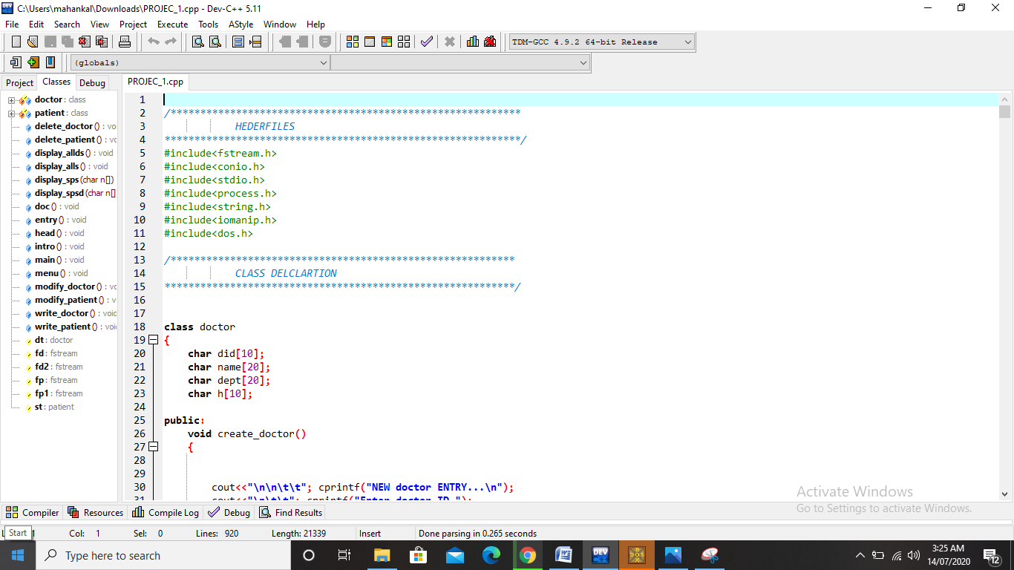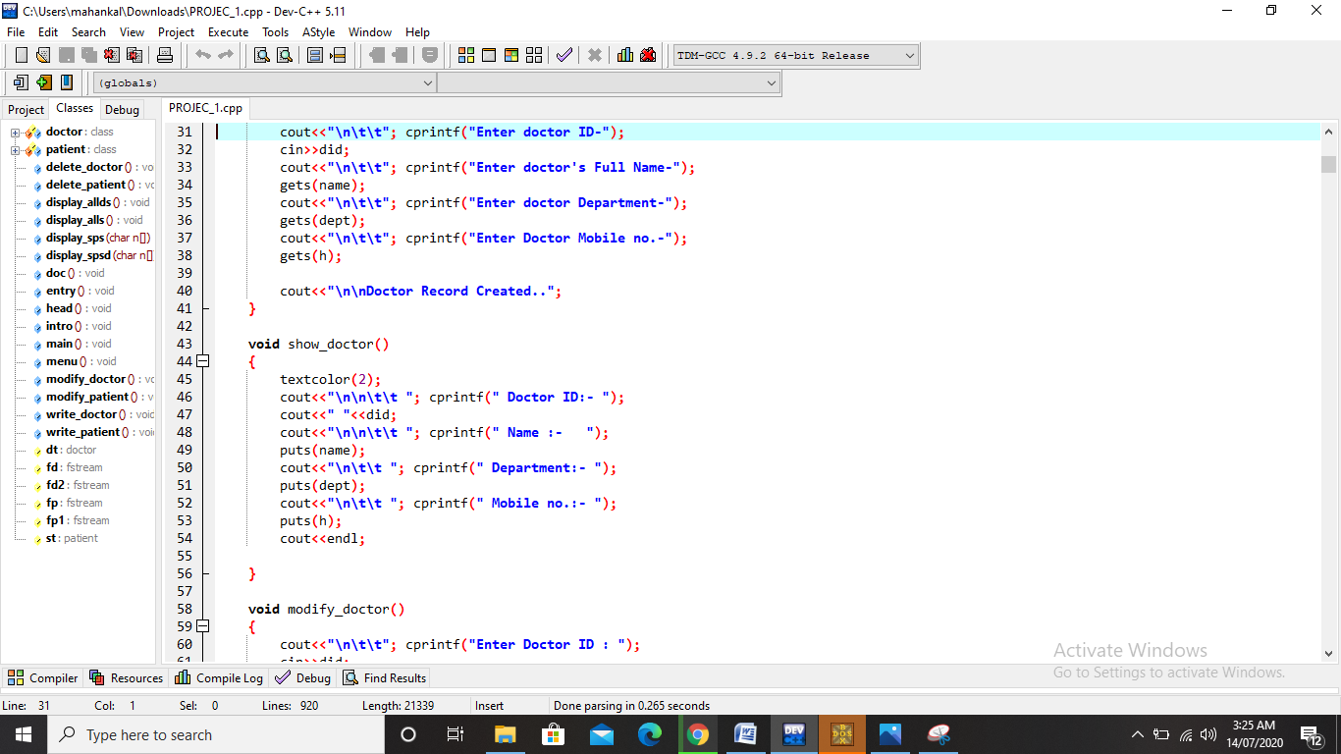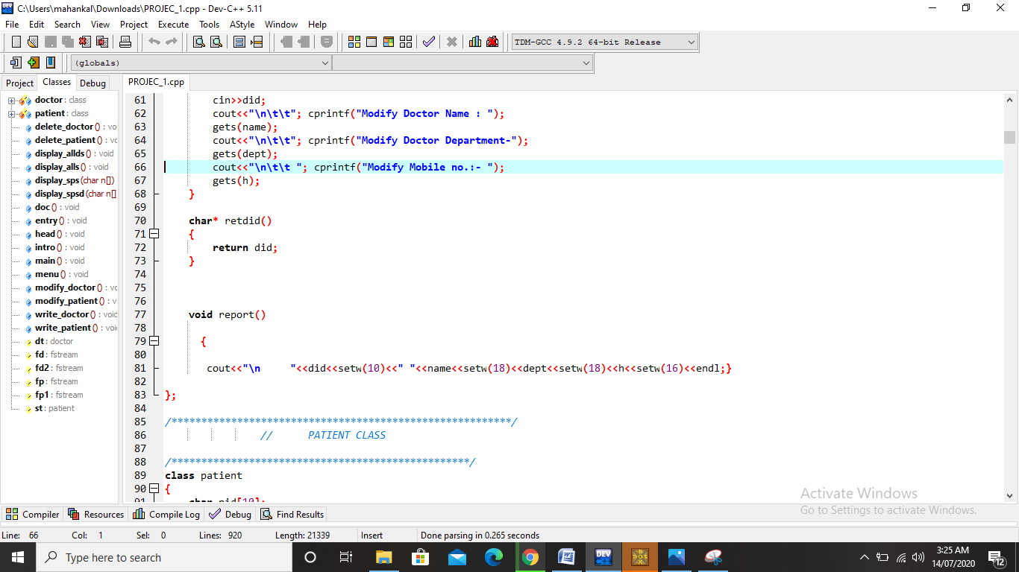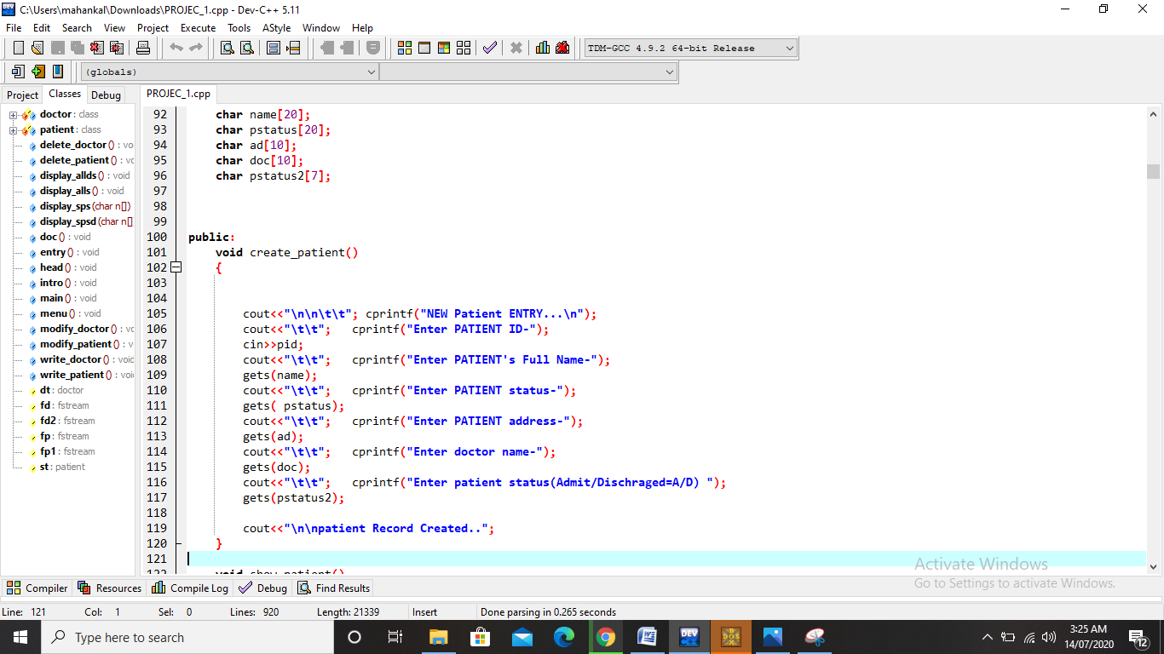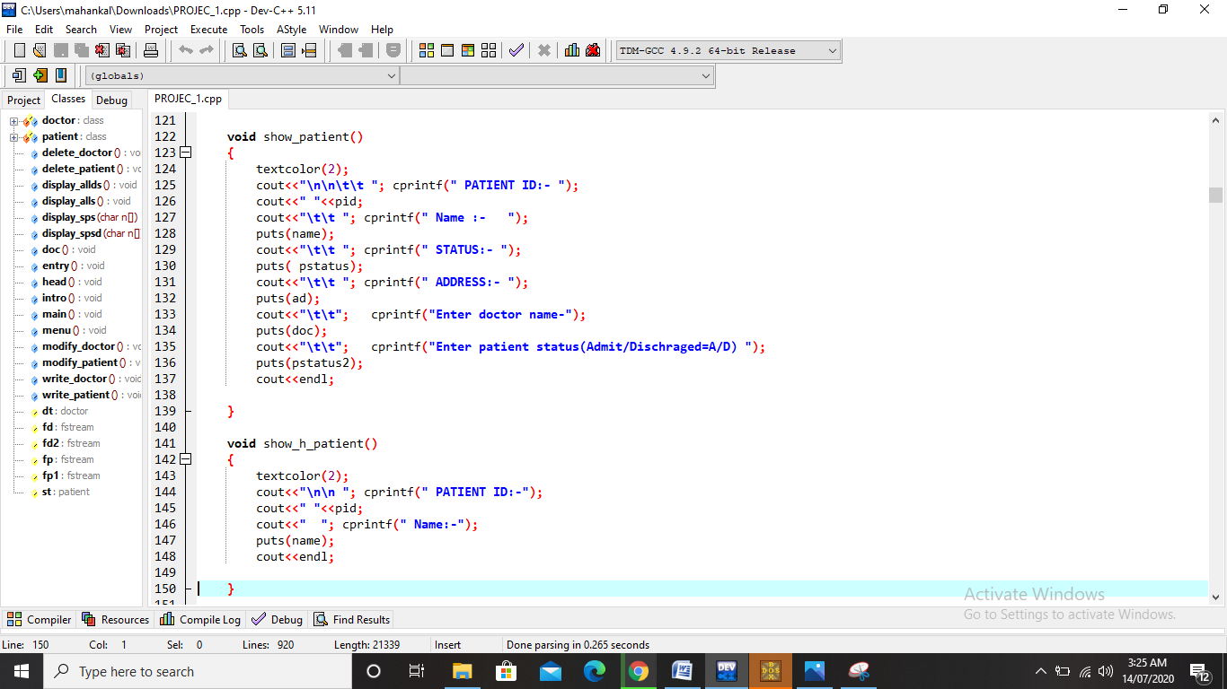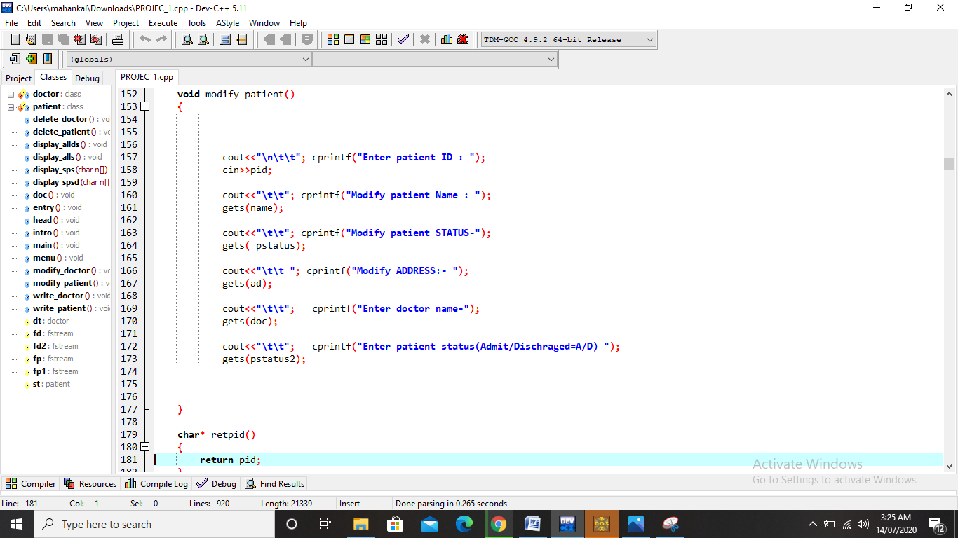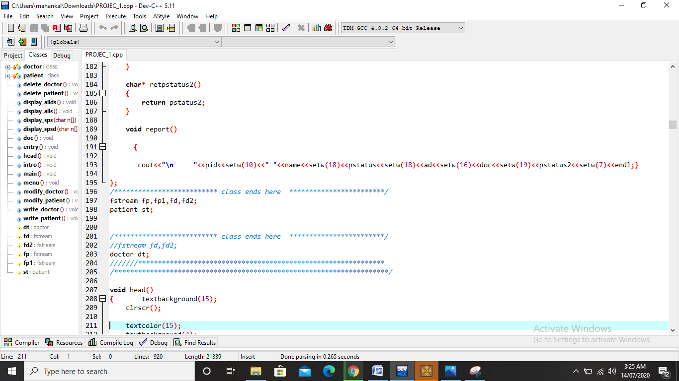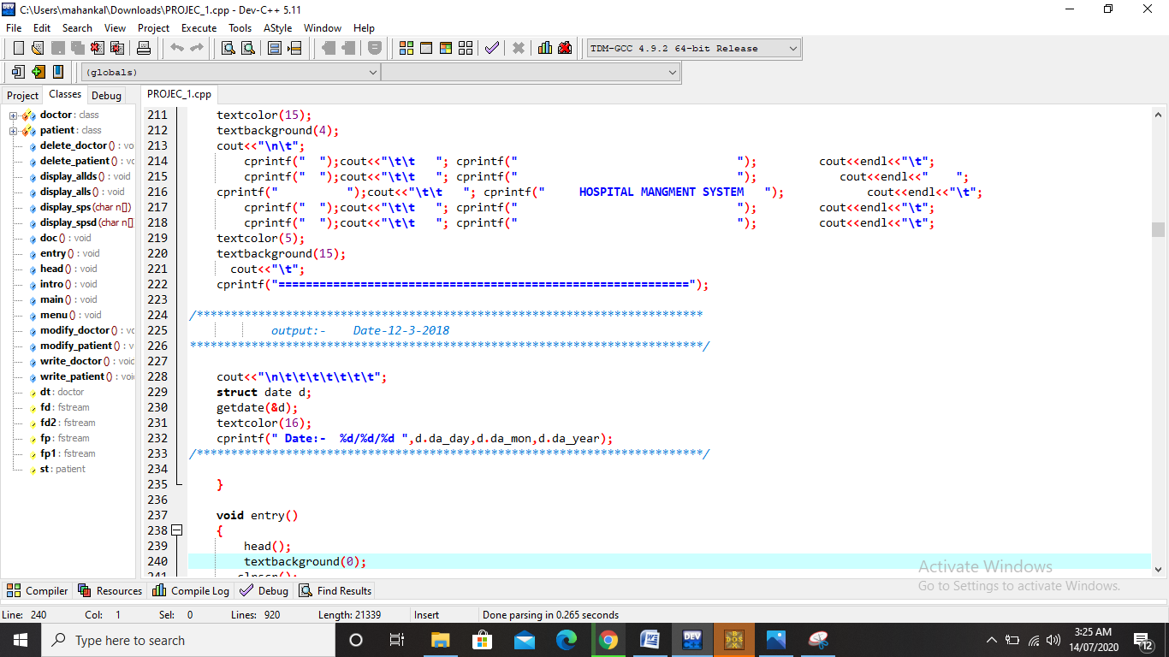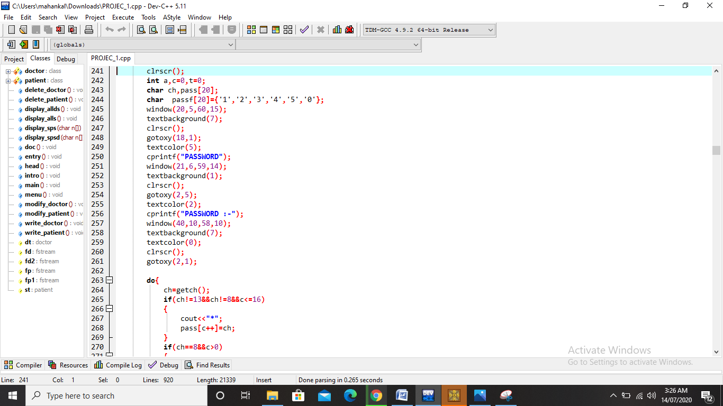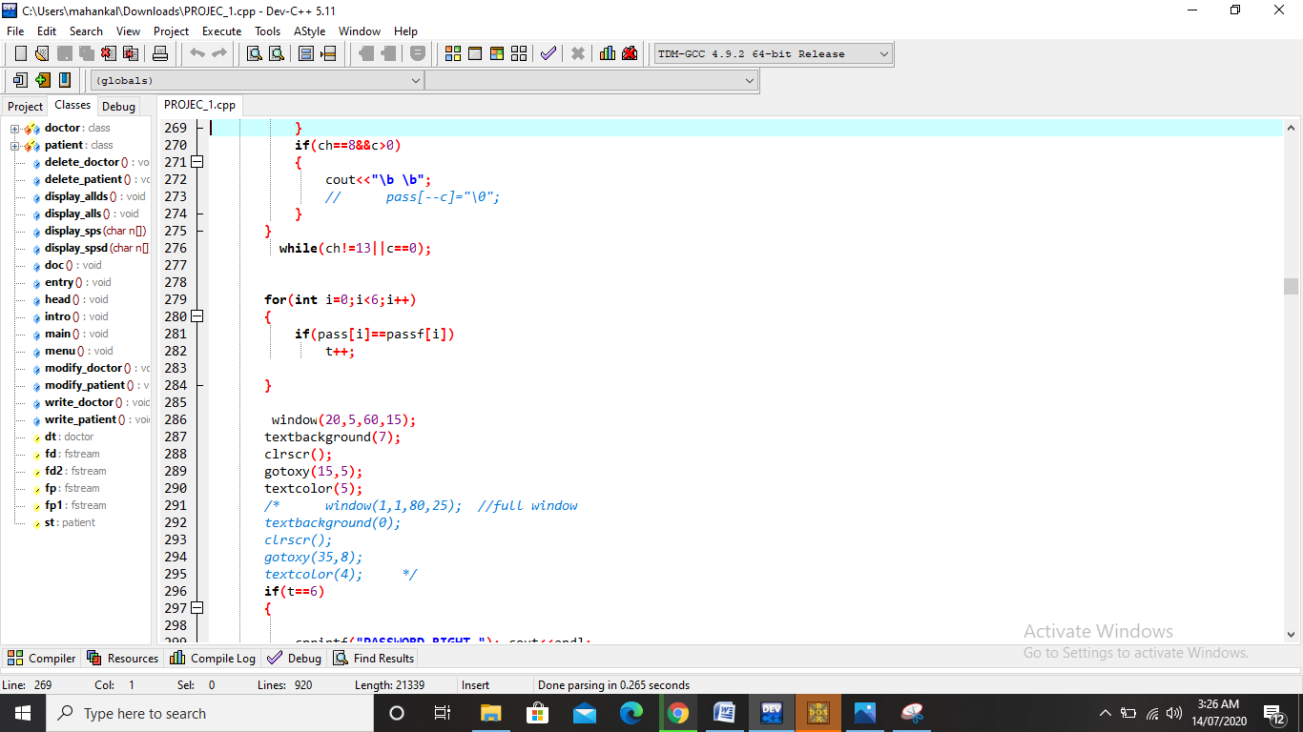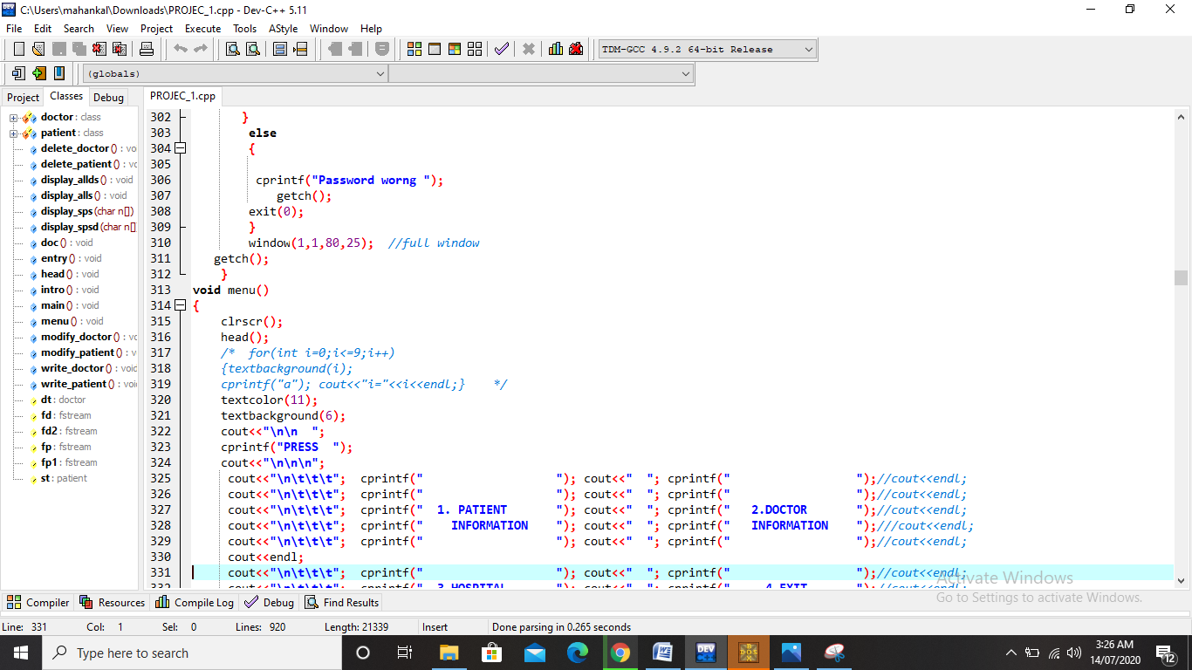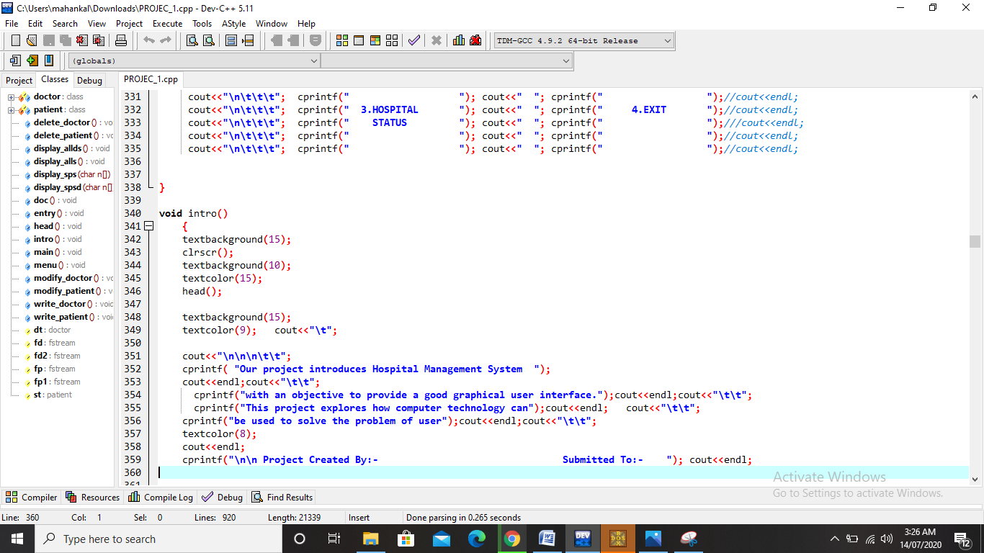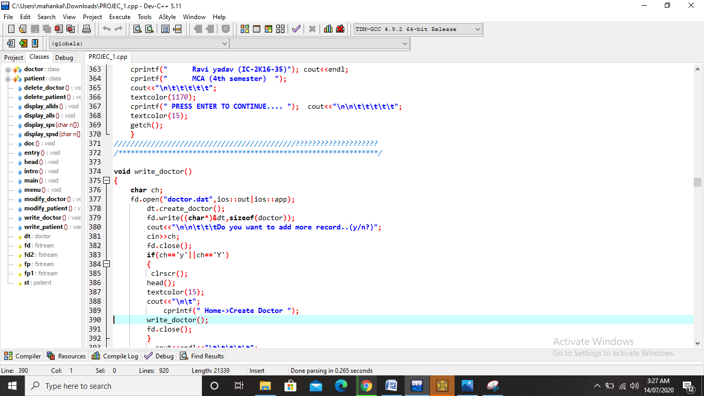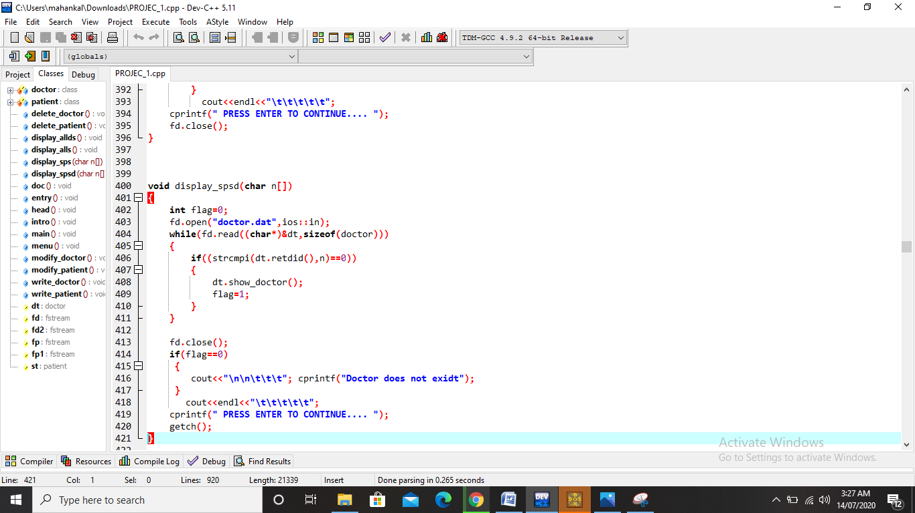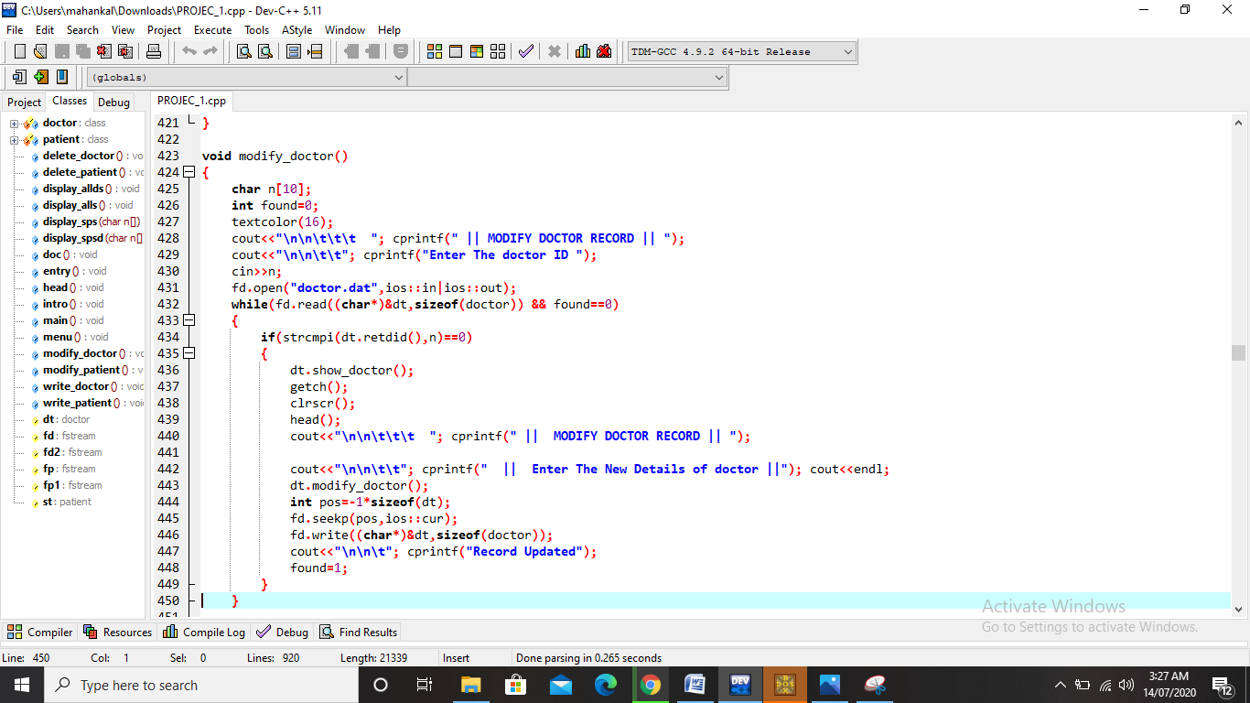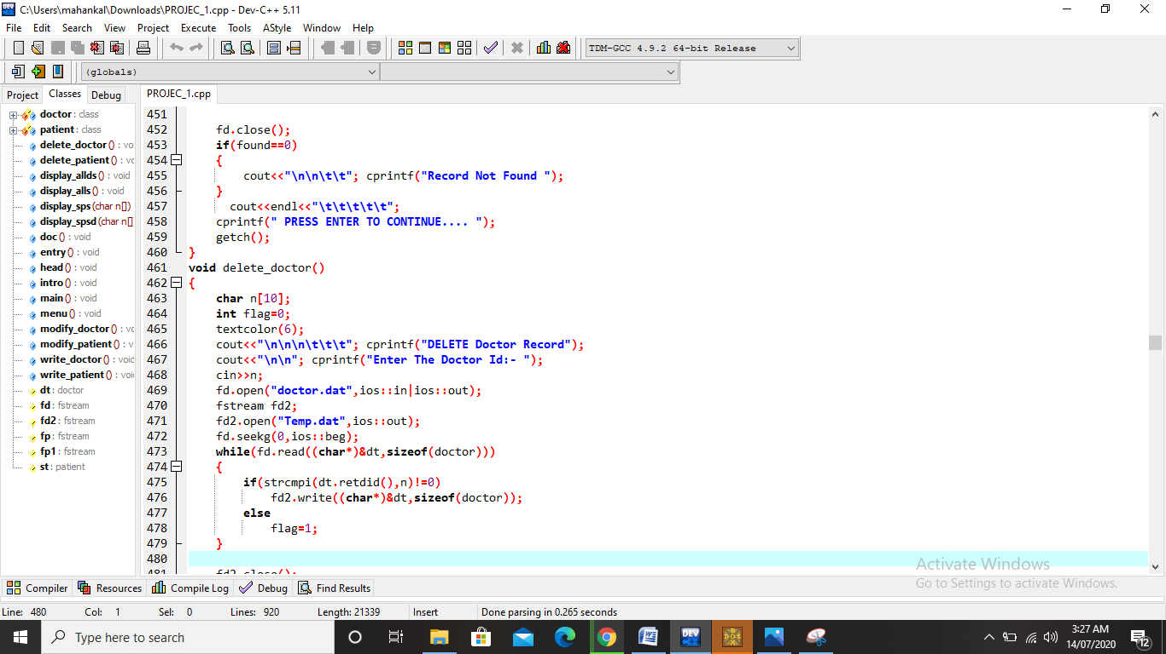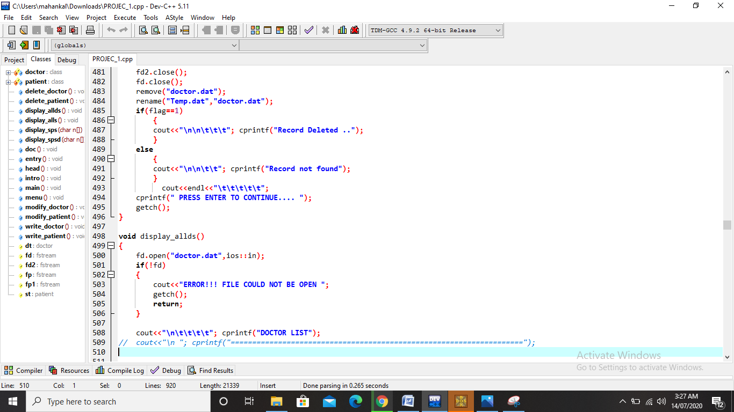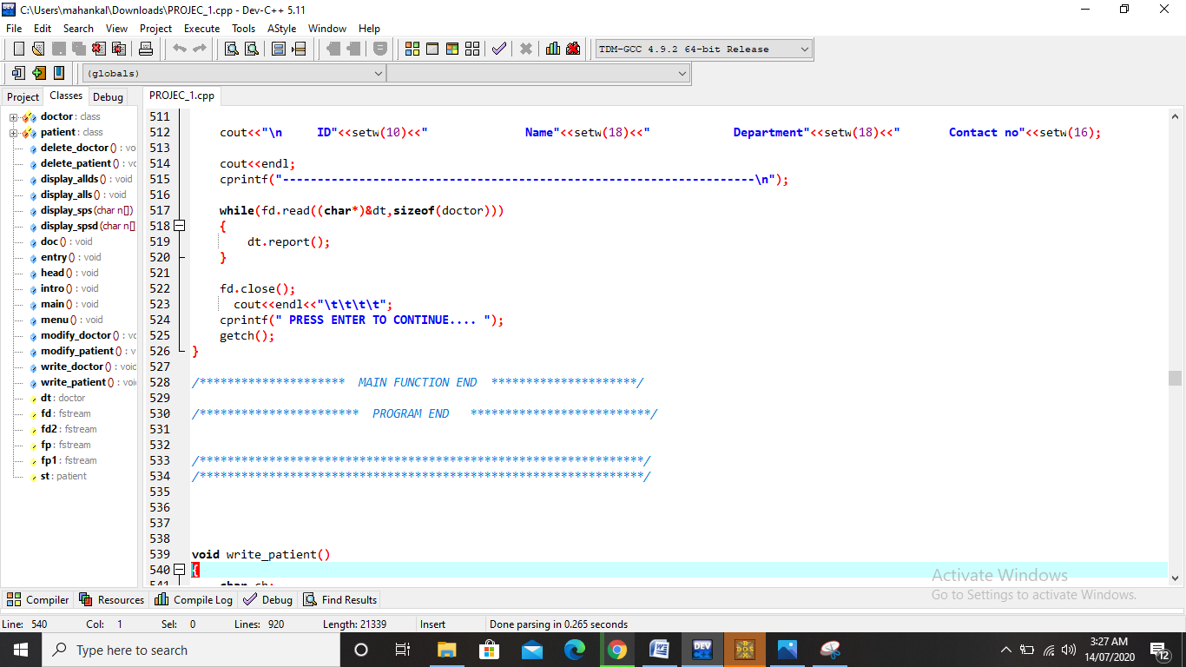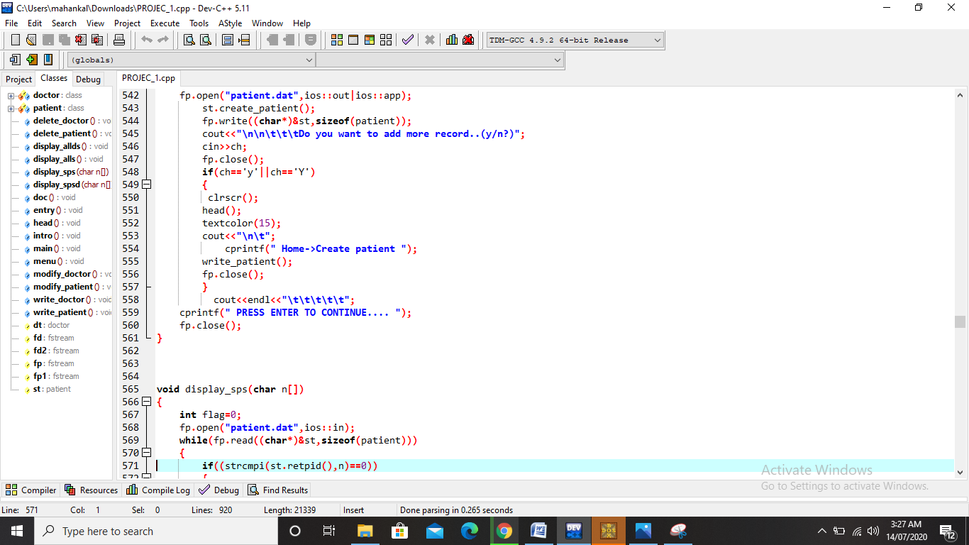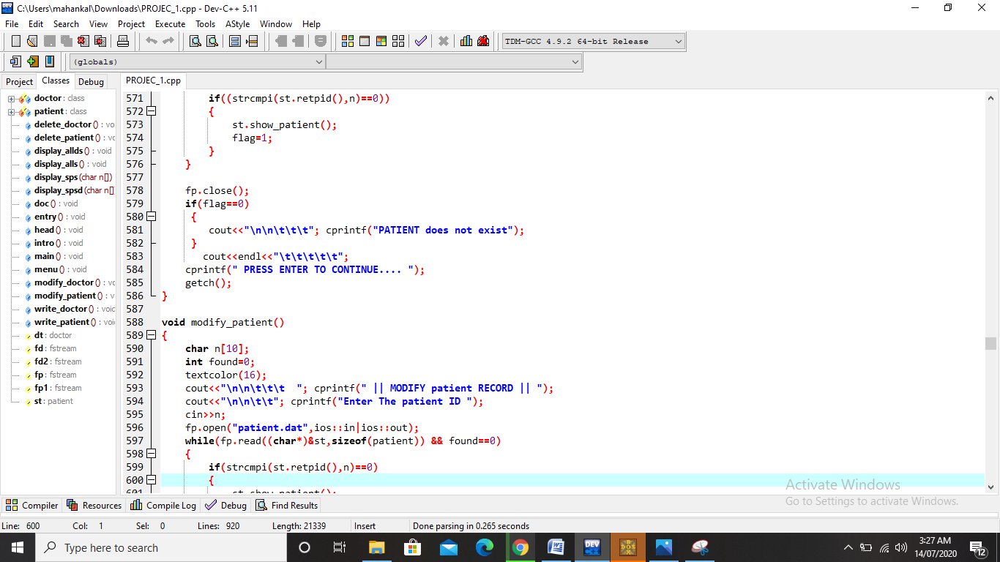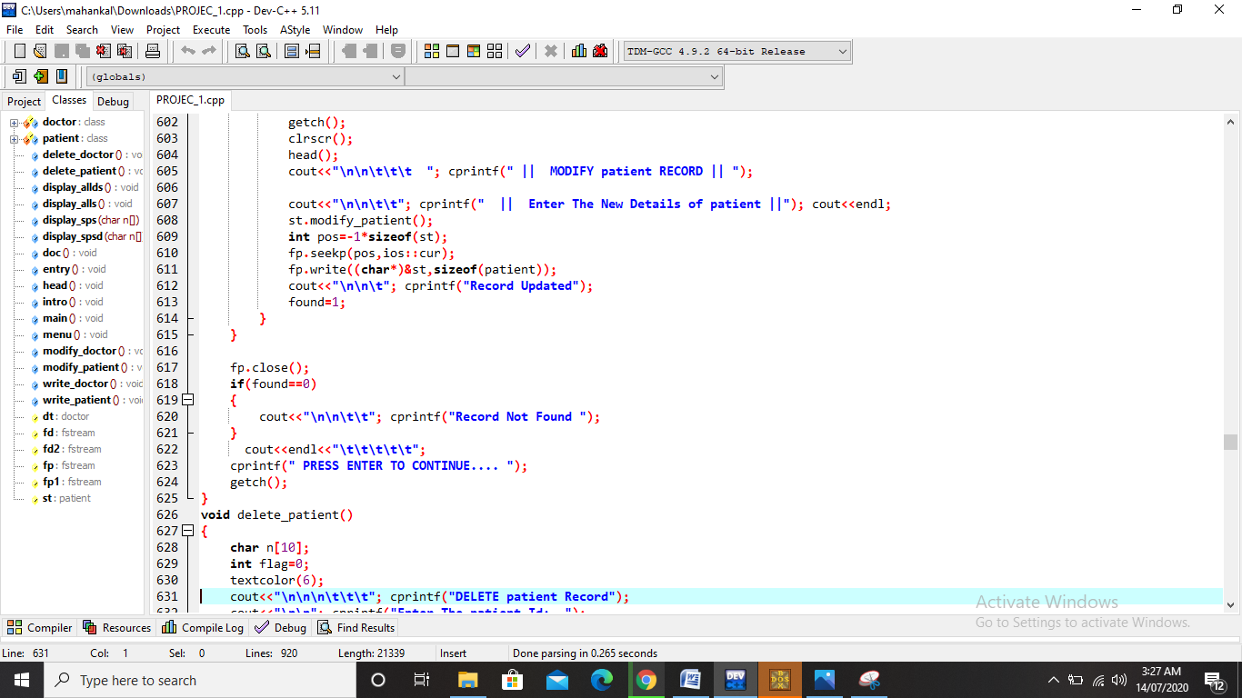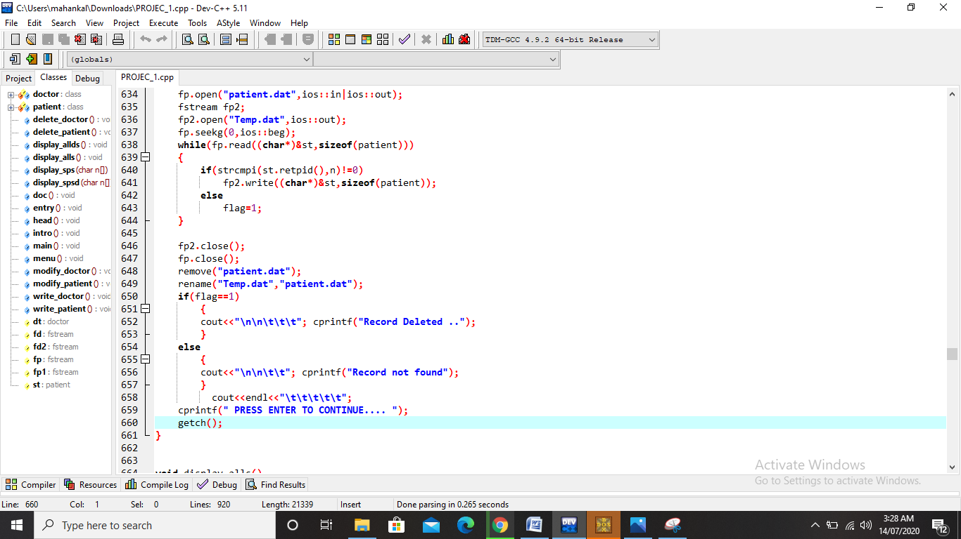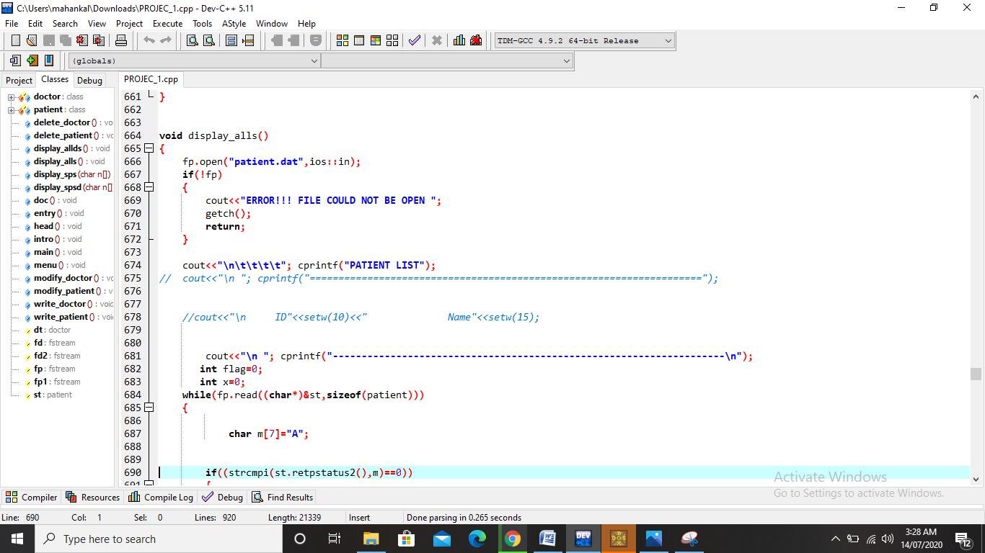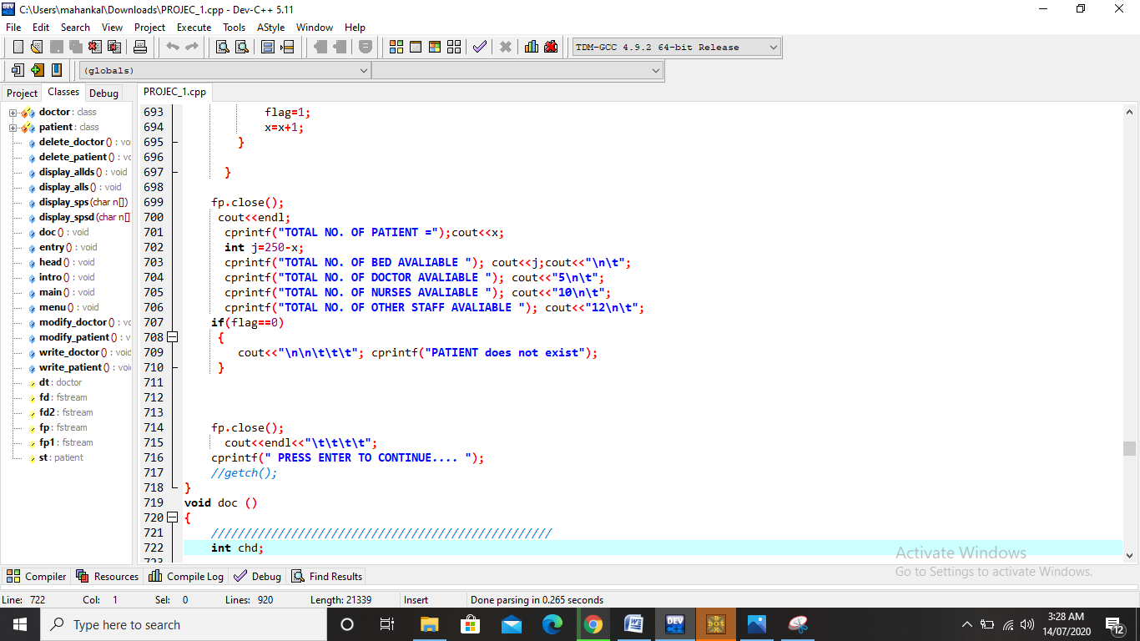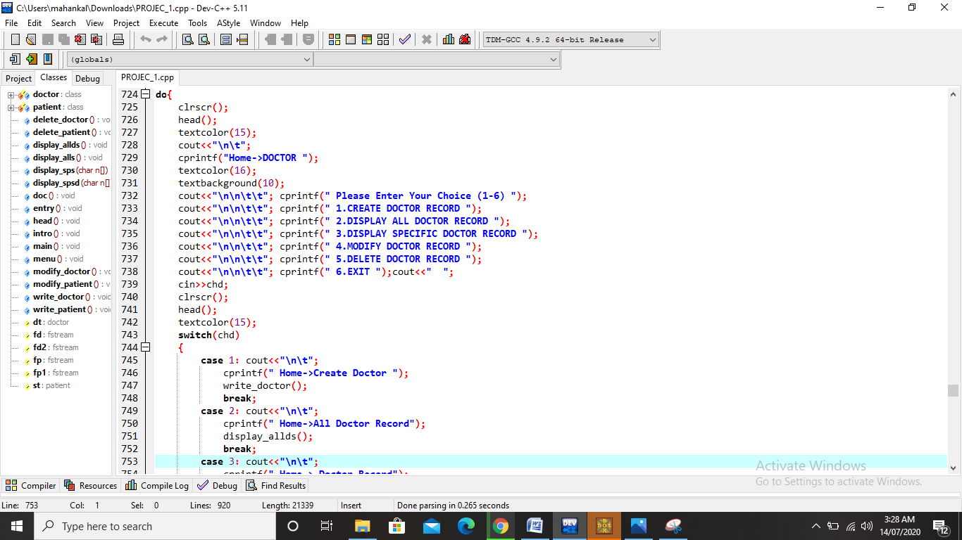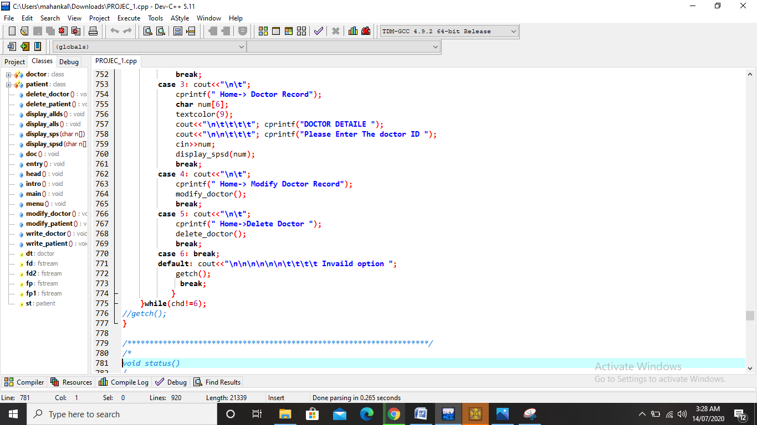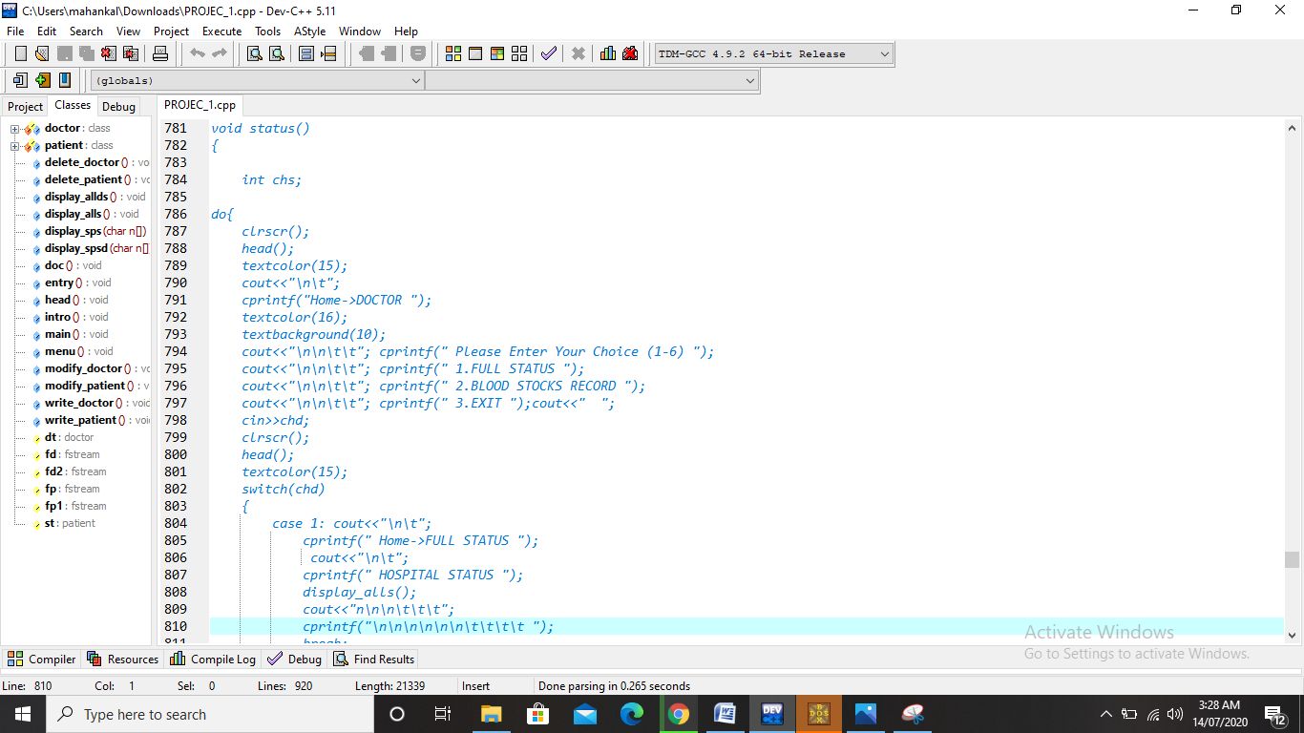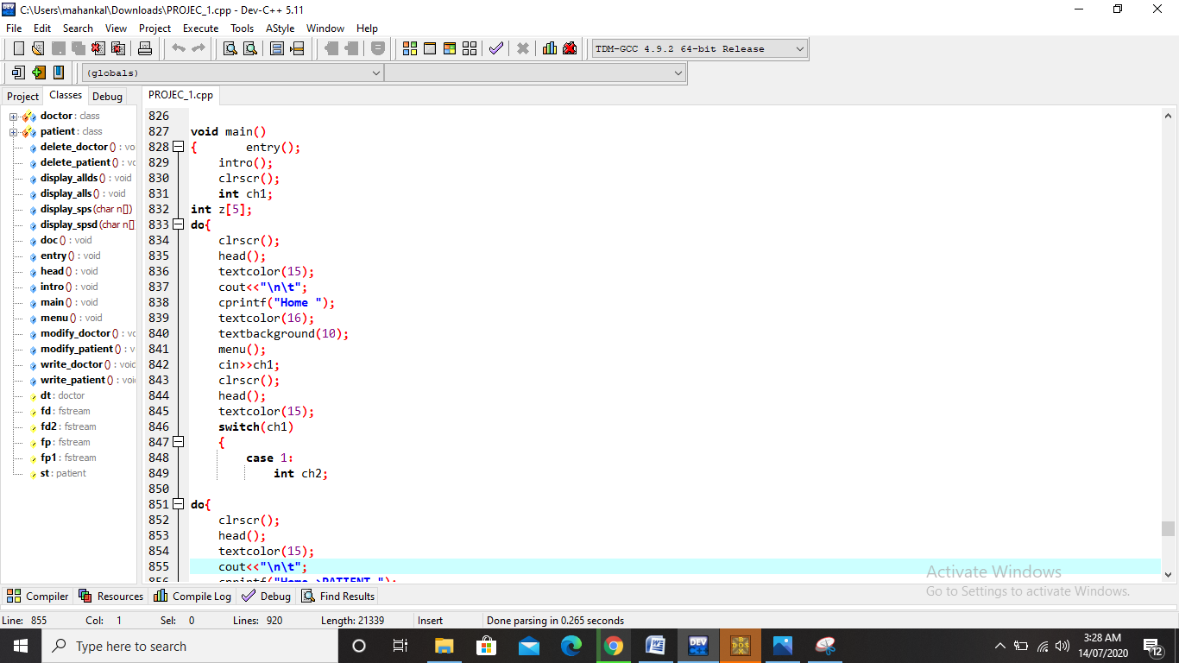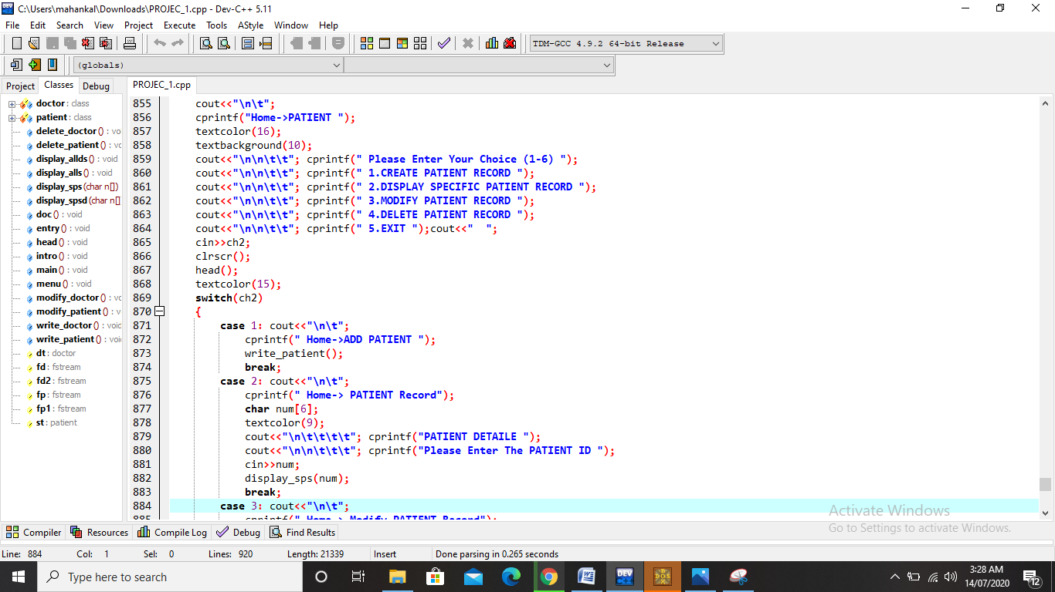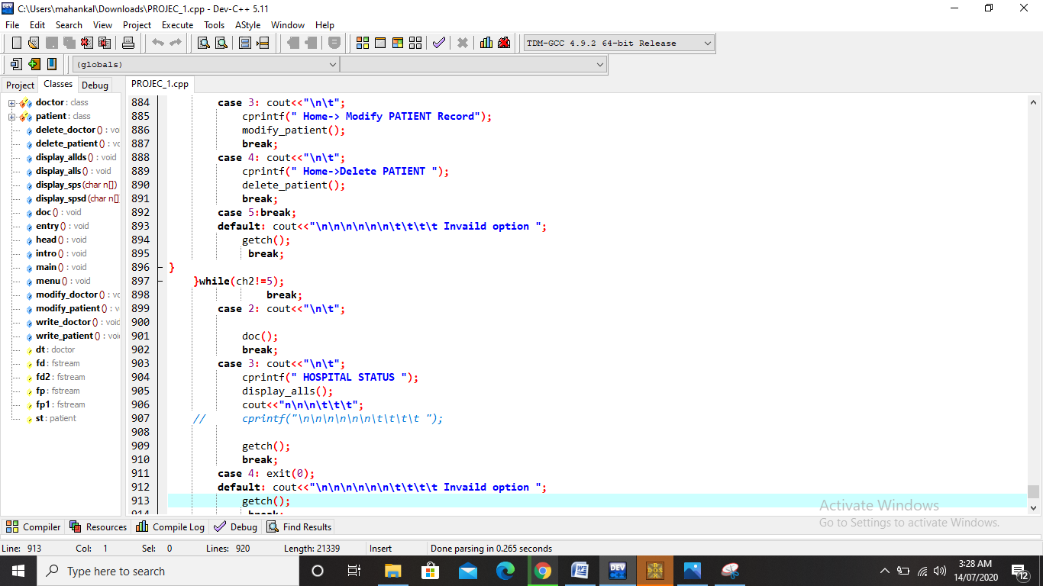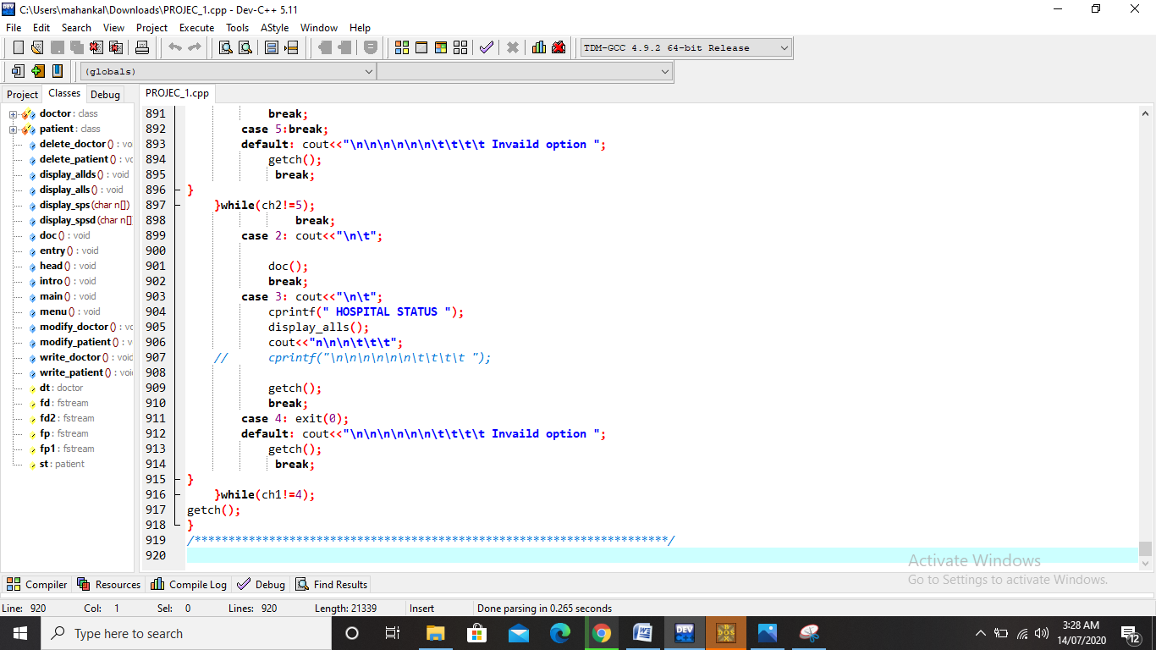

**OUTPUT DISPLAY:**

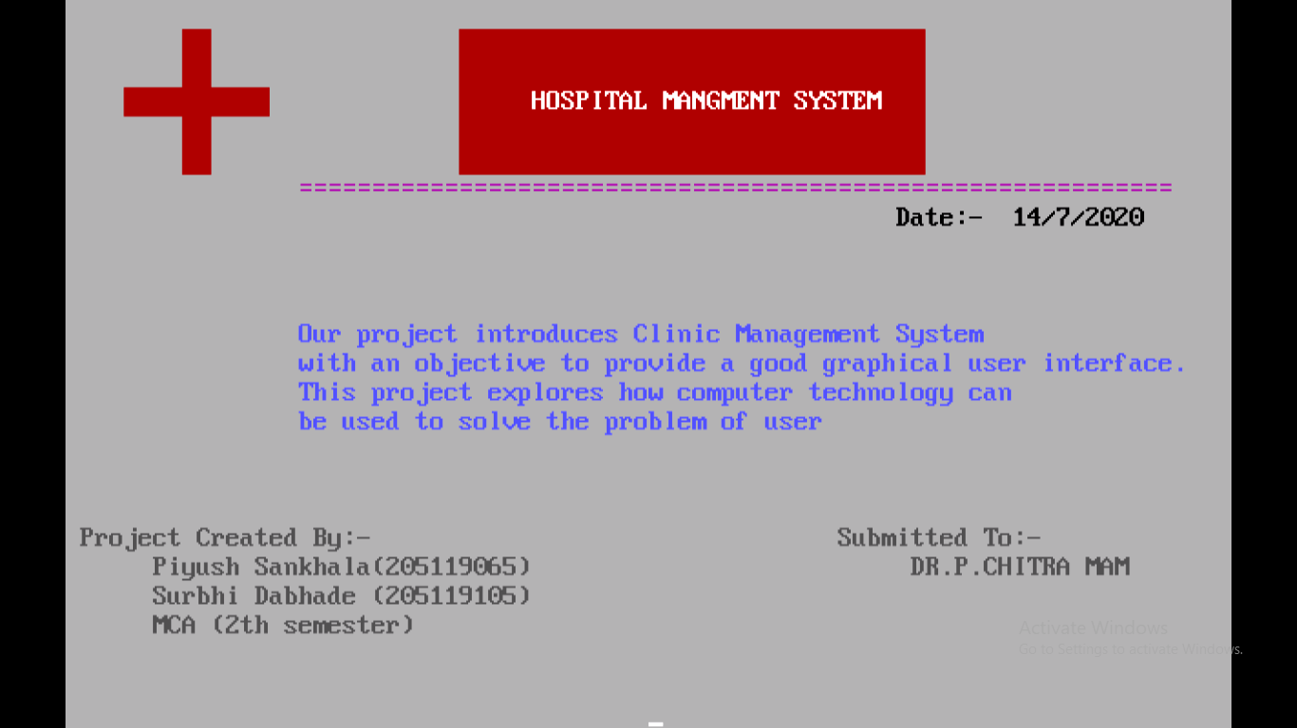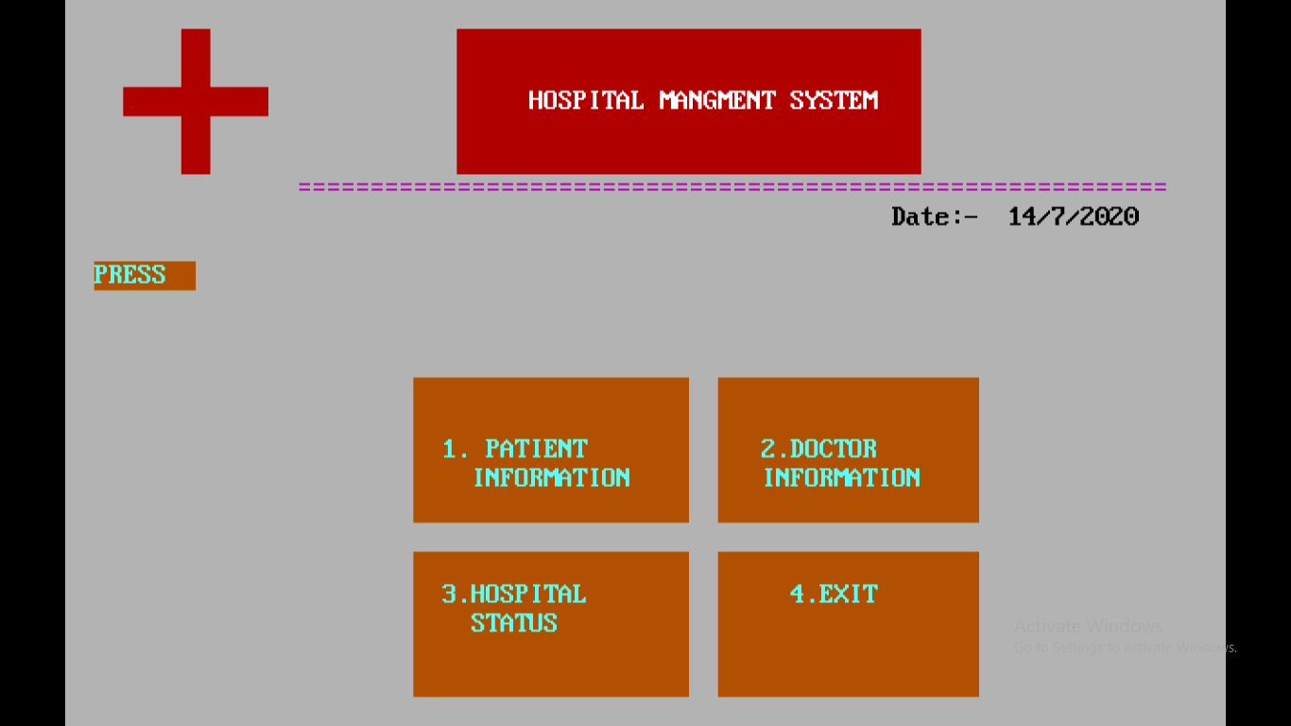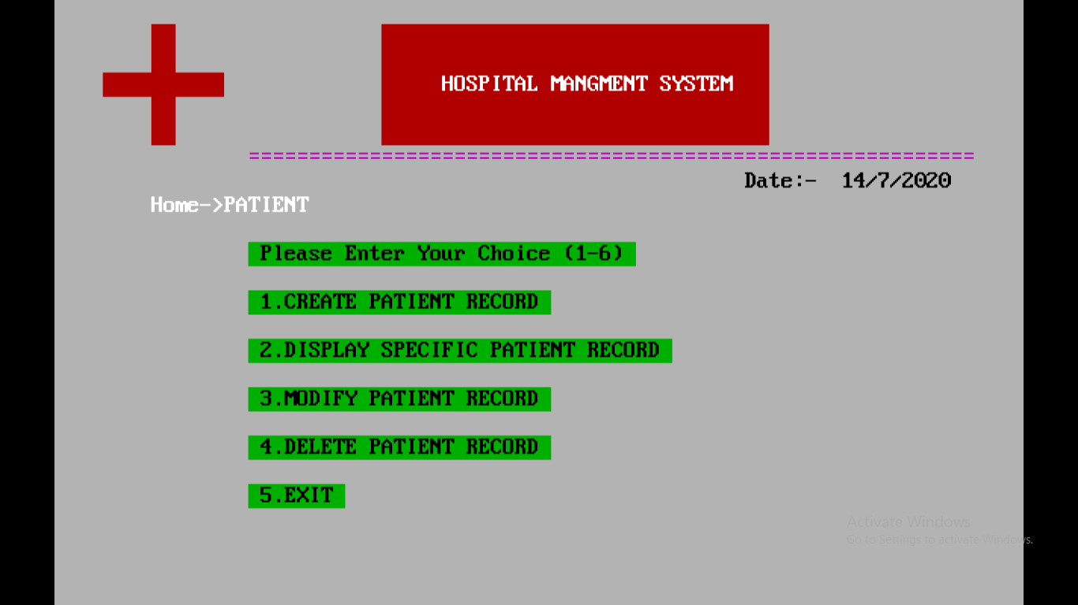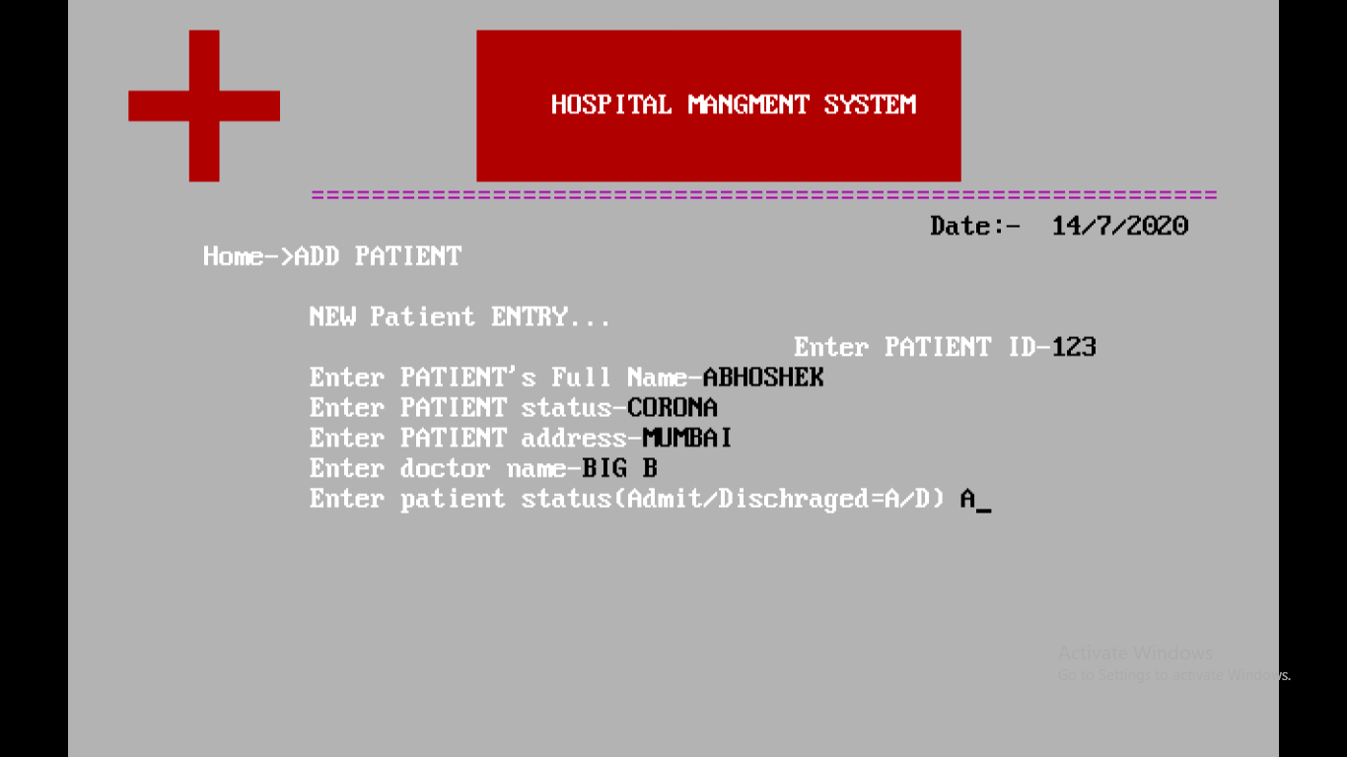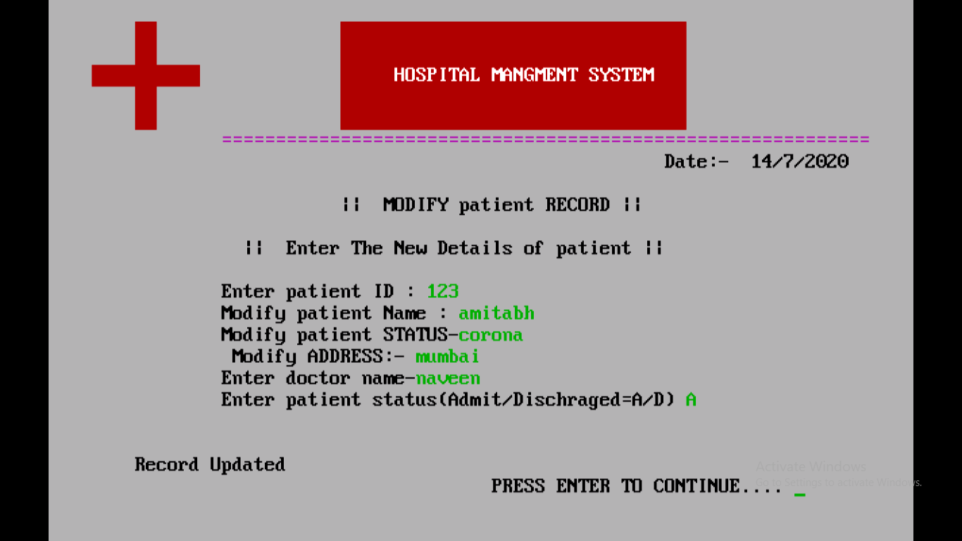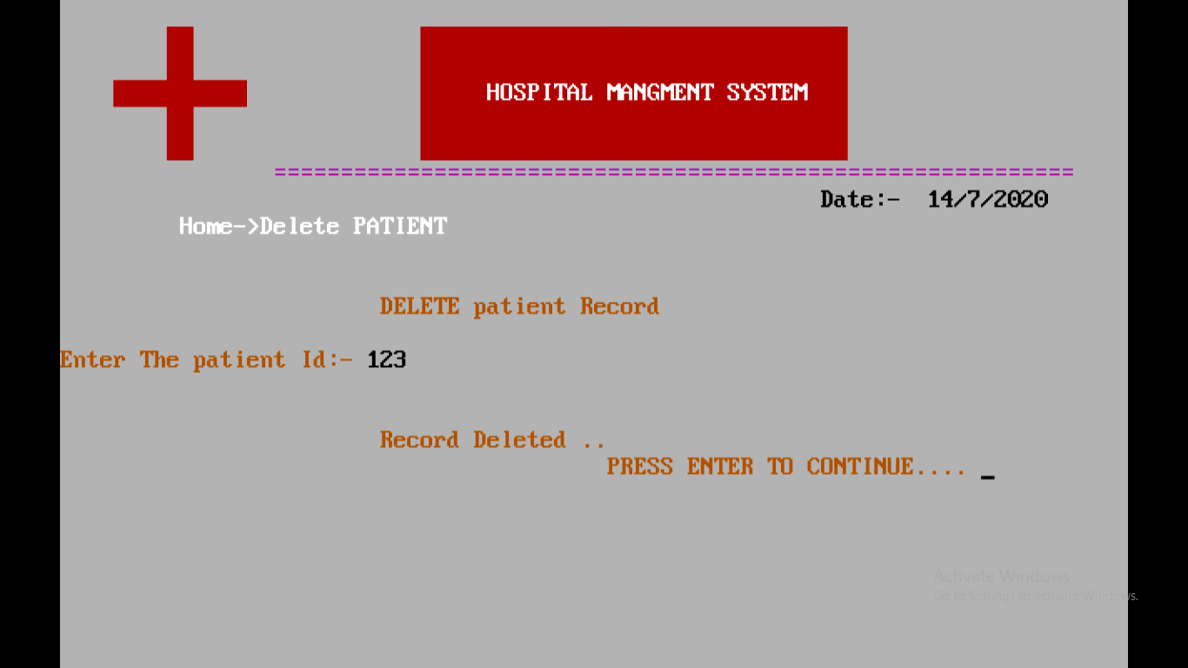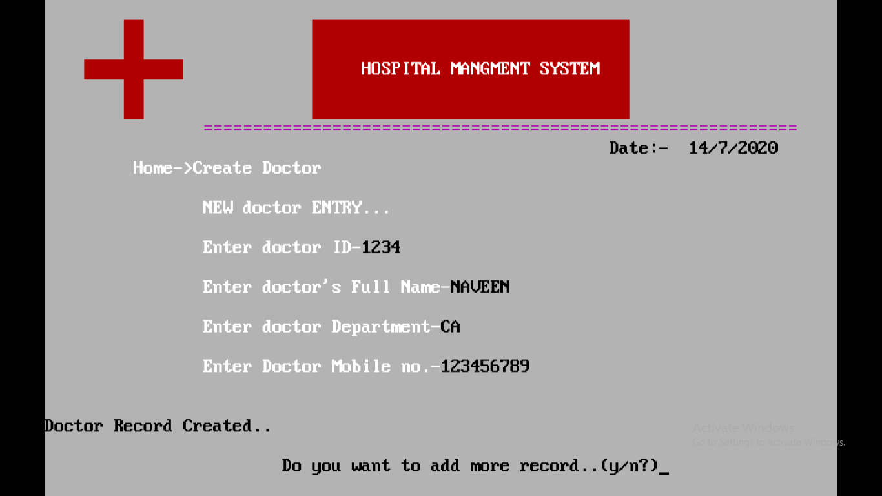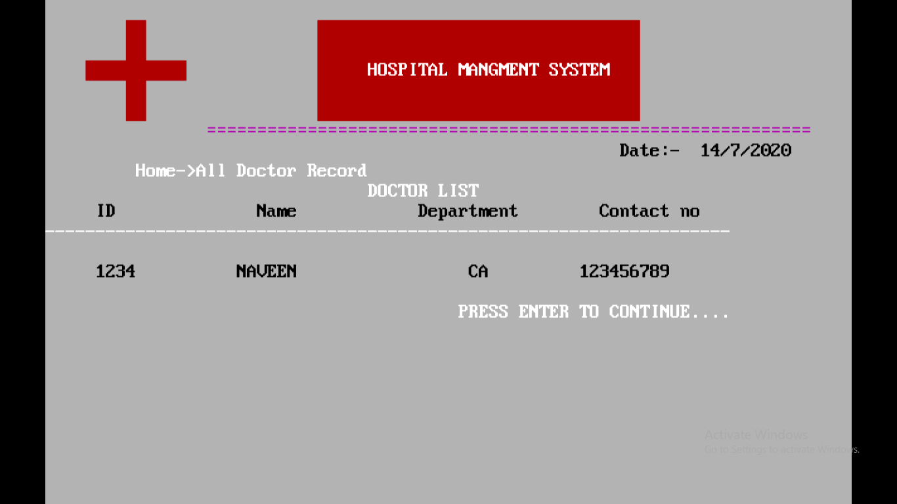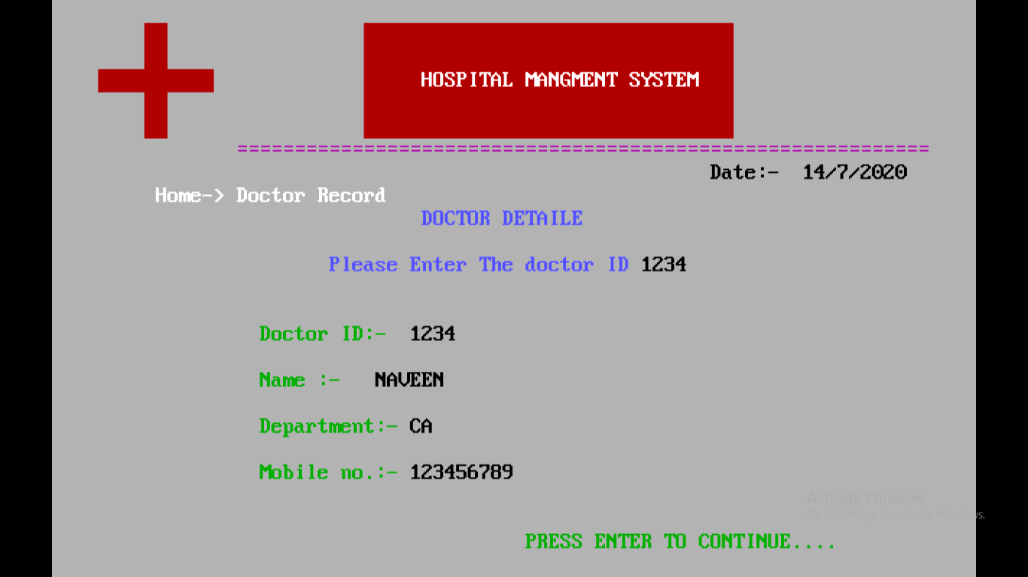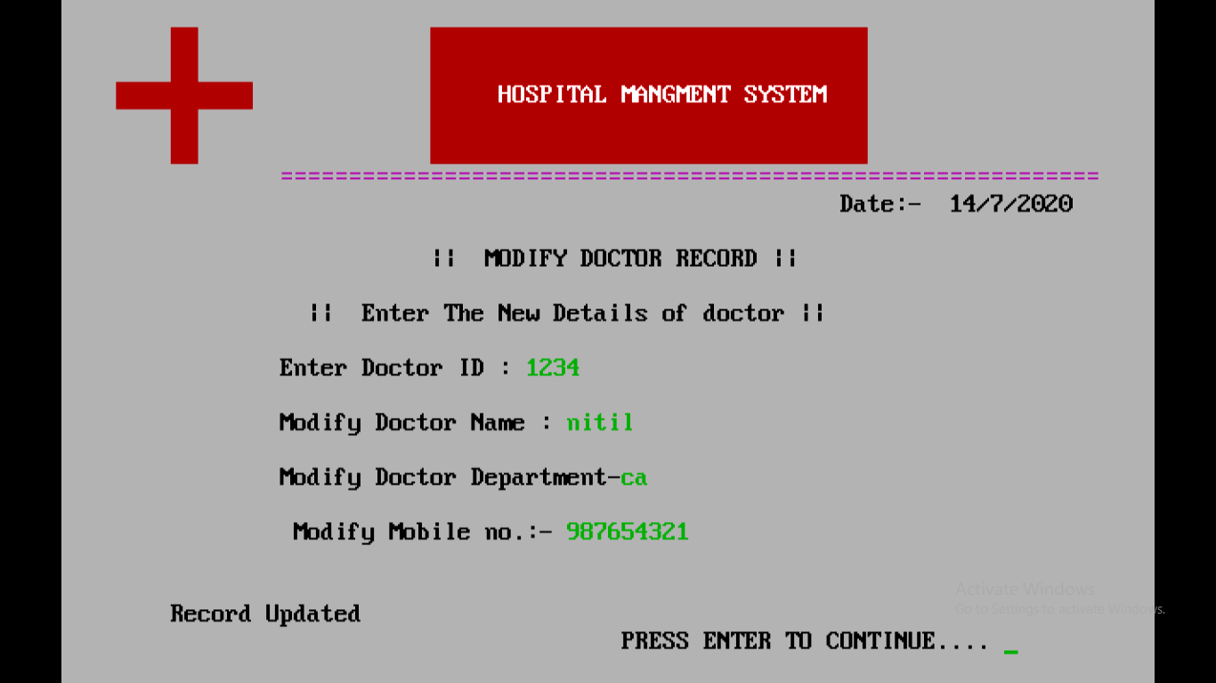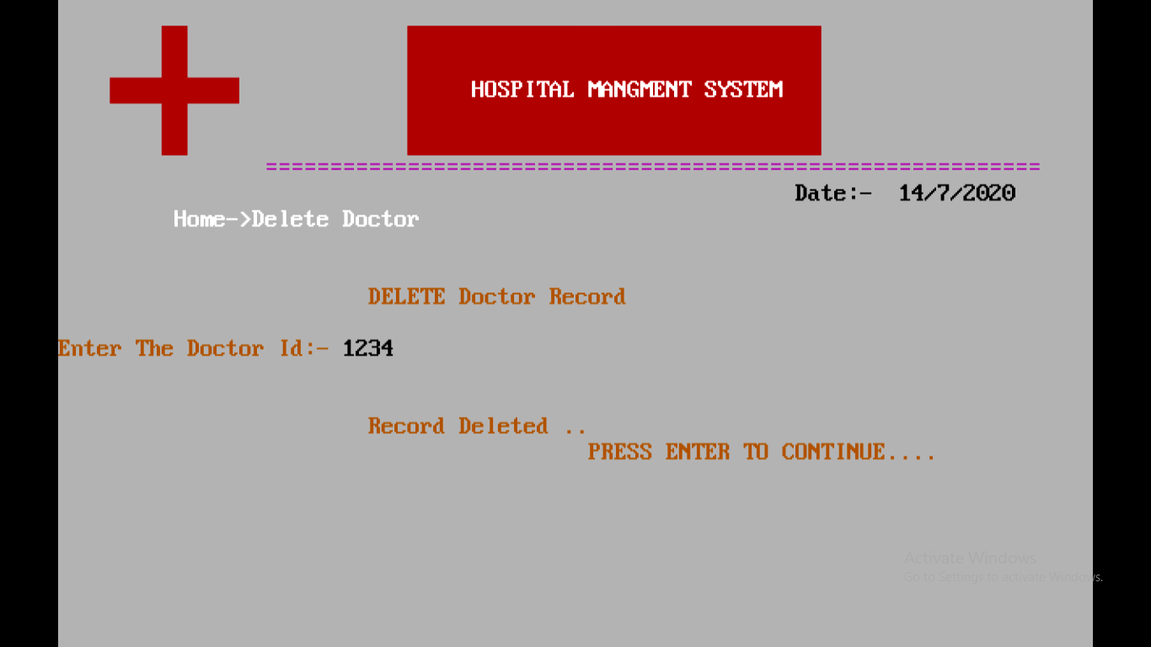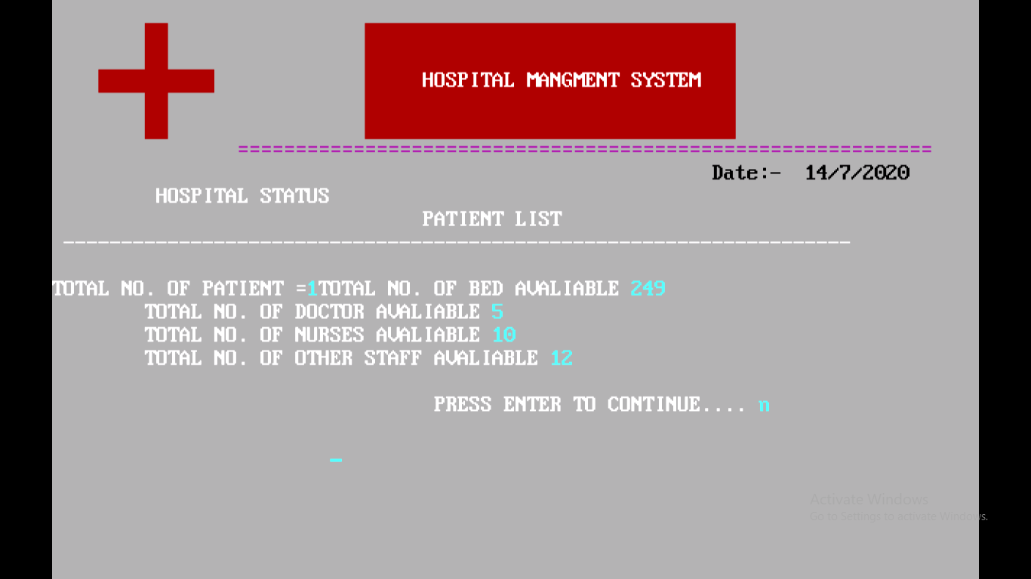

**FUTURE SCOPE OF THE PROJECT**

This project will enhance the patients and the CLINIC to serve more quickly and efficiently. This software is developed in order to computerize the activities which take more time, if done manually.

CLINIC billing system can also be added so that the patient and CLINIC staff to make things faster and can get information quickly. If we want any information about patient, we can access it quickly.

CONCLUSION

Conclusion The project CLINIC management system is for computerizing the working in a CLINIC. The software takes care of all the requirements of an average CLINIC and is capable to provide easy and effective storage of information related to patients that come up to the CLINIC. It is great improvement over the manual system has speed up the process. The CLINIC managing system thoroughly checked and tested with the data and thus is found reliable. The software takes care of all the requirement of an average CLINIC and is capable to provide easy and efficient storage of information related to patients that comes up to the CLINIC. It generates test reports; provide prescription details including various tests, diet advice, and medicines prescribed to patient and doctor. It also provides injection details and billing facility on the basis of patient’s status whether it is an indoor or outdoor patient. The system also provides the facility of backup as per the requirement. The system is secure as a user can modify the information only after the proper authentication. Chances of error are also eliminated to large extent. Computerization and automation of the whole system helps in easy and fast access to the required information. The system is highly user friendly as appropriate message are provided to guide the user logged in.

36. 36 7.2 Scope of future Work:

The CLINIC management system can enhance by including more facility like pharmacy system for the stock details of medicine in pharmacy. Providing each future enable the users to include more comment in the system.Although the project is complete in itself but as there is always a future scope for improvement; the same applies to this software. The provision for getting appointment from the doctor through Internet, i.e., Online Appointment facility can be added. The doctor could view the requests from several patients and accordingly give the appointment if possible. Further, Mobile Application can be implemented to allow the patients to view their previous visit details and get appointment from doctors through mobiles. Posting of employees from one CLINIC to another can also be managed. Further, doctors can be given the provision to post their articles on the website of CLINIC.It generates test reports; provide prescription details including various tests, diet advice, and medicines prescribed to patient and doctor. It also provides injection details and billing facility on the basis of patient’s status whether it is an indoor or outdoor patient. The system also provides the facility of backup as per the requirement.

**Bibliography**

WEBSITE:

1. [www.tutorialpoints.com](http://www.tutorialpoints.com/)

2. [www.programmer2programmer.co.uk](http://www.programmer2programmer.co.uk/)

BOOKS RECOMMENDED:

1. [Let Us C By- Yashavant Kanetkar](https://www.google.co.in/url?sa=t&rct=j&q=&esrc=s&source=web&cd=5&cad=rja&uact=8&ved=0ahUKEwih5rrN-JvTAhXFwI8KHeBMDBgQFgg1MAQ&url=https%3A%2F%2Fwww.pinterest.com%2Fpin%2F507288345500242420%2F&usg=AFQjCNHFht1UfomtvNcy1e1H5iU2JGGiaQ&sig2=gFWPforL2JbOhuFPqscjGg&bvm=bv.152180690,d.c2I)

2. [E Balagurusamy -Object Oriented Programming With C++](https://www.google.co.in/url?sa=t&rct=j&q=&esrc=s&source=web&cd=5&cad=rja&uact=8&ved=0ahUKEwjz76b4-JvTAhWLrI8KHforDDsQFgg4MAQ&url=https%3A%2F%2Farchive.org%2Fdetails%2FEBalagurusamyObjectOrientedProgrammingWithC&usg=AFQjCNFSXOho3-ny4vLl0tHeFncKfX4YDw&sig2=n47VipIcsWtSVKHg7FtnkA&bvm=bv.152180690,d.c2I)